Create DB2 and connect python

|  |  |
| --- | --- |
| Date | 17 November 2022 |
| Team ID | PNT2022TMID14116 |
| Project Name | Smart Fashion Recommender Application |

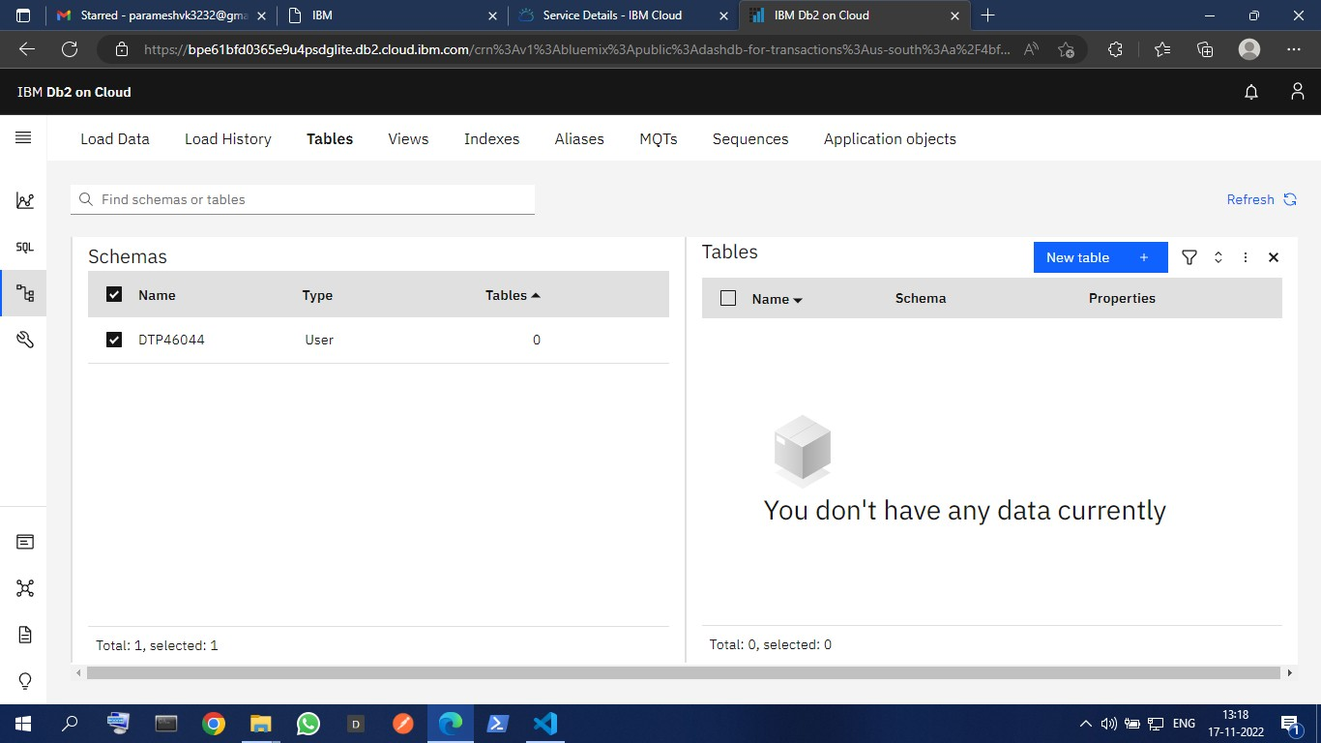CREATING IBM DB2

CONNECT WITH PYTHON CODE

